

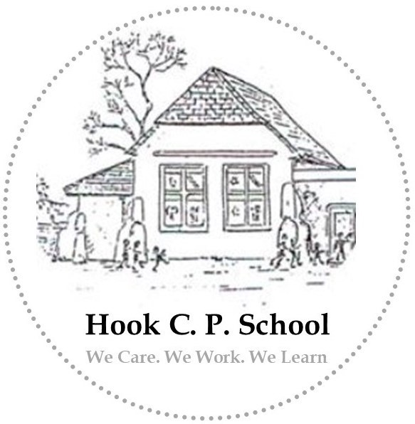
Governing Body

Annual Report to Parents

2024-2025

@hookprimary

www.ysgolhook.co
m

@hook_primary

Welcome / Croeso

A message from the Chair of Governors
Dear Parent/Carer,
As a regular visitor to school, it is a delight to witness and feel part of the wonderful ethos at Hook C. P. The school year was as busy as ever. For those that have managed to attend class assemblies, whole-school performances or even one of the open day events will have seen for themselves, the excellent teaching and learning that takes place daily.
The school has continued to develop in all areas and it is exciting to learn of the plans to further enhance teaching and learning with the focus on outdoor learning. Already, parents are beginning to help with this important work, and I am sure, will continue to do so. On behalf of the Governing Body, may we thank all parents for their kind support throughout the year – this is vitally important to the success of our school.
In addition to outdoor learning, our children are also enjoying a range of musical, artistic and sporting activities - including some friendly rivalries with local schools. I know Mr Williams is working with other Headteachers to plan the sporting calendar for the year at this time.
Overall, as a Governing Body, we are pleased with the commitment shown by all. I would like to thank all pupils, staff, parents and colleague Governors for their support throughout the year. I hope you'll take the opportunity to see for yourself how thriving and vibrant our school is at one of the many events over the coming months.
Thank you for your ongoing support.
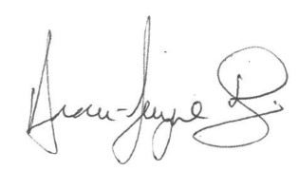

A message from the Headteacher
Dear Parents and Carers,
Despite the fact that I have only been working at Hook School for a short period, I have thoroughly enjoyed meeting pupils and feeling a part of the Hook Community. Having worked in large town schools, the uniquely nurturing nature of Hook School and the relationships which pupils develop across year groups has been wonderful to observe. I look forward to continuing to build upon strong foundations and celebrating the successes of our school community.
During the academic year 2024-2025 the school has continued to make strong progress, developing Curriculum for Wales and embedding high quality teaching and learning. We have a clear focus on core standards in language and mathematics and pupil progress in each progression step is a positive feature of the school.
It continues to be a privilege to lead the school and its fantastic team. Moving forward, we will continue to do all we can to ensure our pupils are provided with the best learning experiences and continue to care, work and learn together.

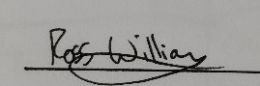
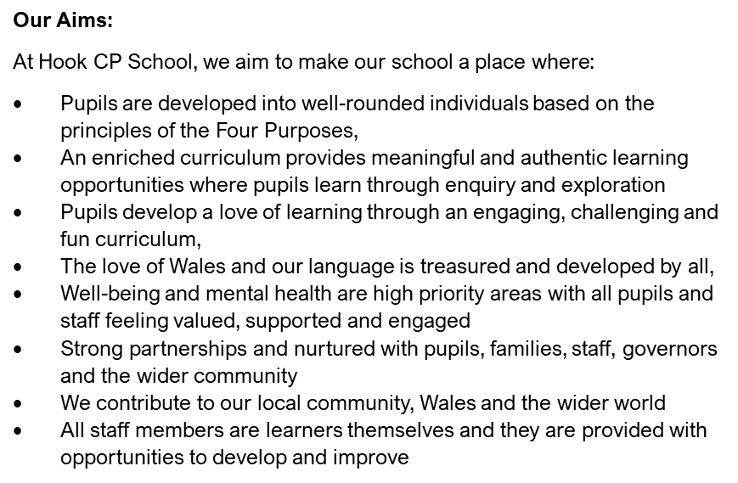
Our Aims

Our Values
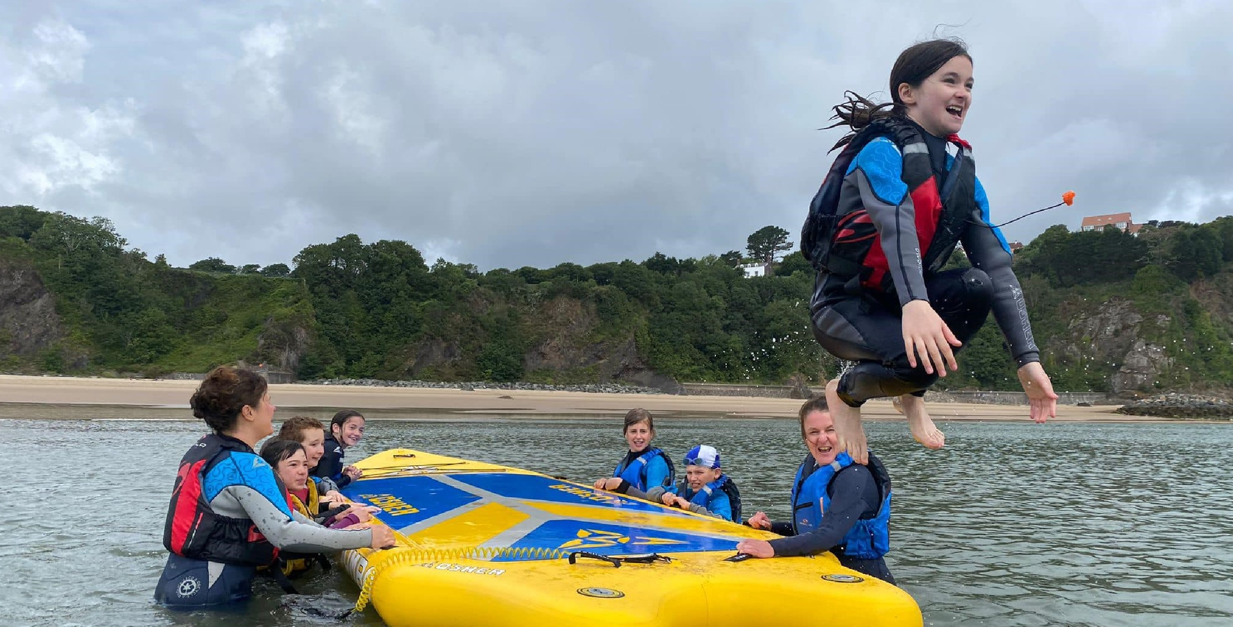
We follow the Values Based Education scheme to ensure our pupils are nurtured to become well-rounded individuals. Teaching pupils from a young age about empathy, freedom, humility, unity and tolerance is vitally important. We link values to United Nations Rights of the Child in order to ensure our pupils are developed as citizens of Wales and wider world.

Governing Body Structure
Chair of Governors (Parent Governor) | Mrs Anna-Jayne Harries
Vice Chair (Local Authority Governor) | Cllr. Michael John
Acting Headteacher | Mr Ross Williams
Teacher | Mrs Amy Rodriguez
Community | Mrs Shirley Burt
Additional Community Governor | Mr Keith Hancock
Parent | Mr Justin Owen-Harris
Community | Mrs Rhiannon James
The Full Governing Body meet as a minimum on a termly basis to discuss the overall strategic direction of the school. Governors hold the Headteacher and members of staff accountable for all aspects of school life including standards, wellbeing, and curriculum readiness.

In addition to the above, governors meet throughout the year to attend specific committee meetings. Committees such as curriculum development, finance, safeguarding and heath & safety occur more regularly.

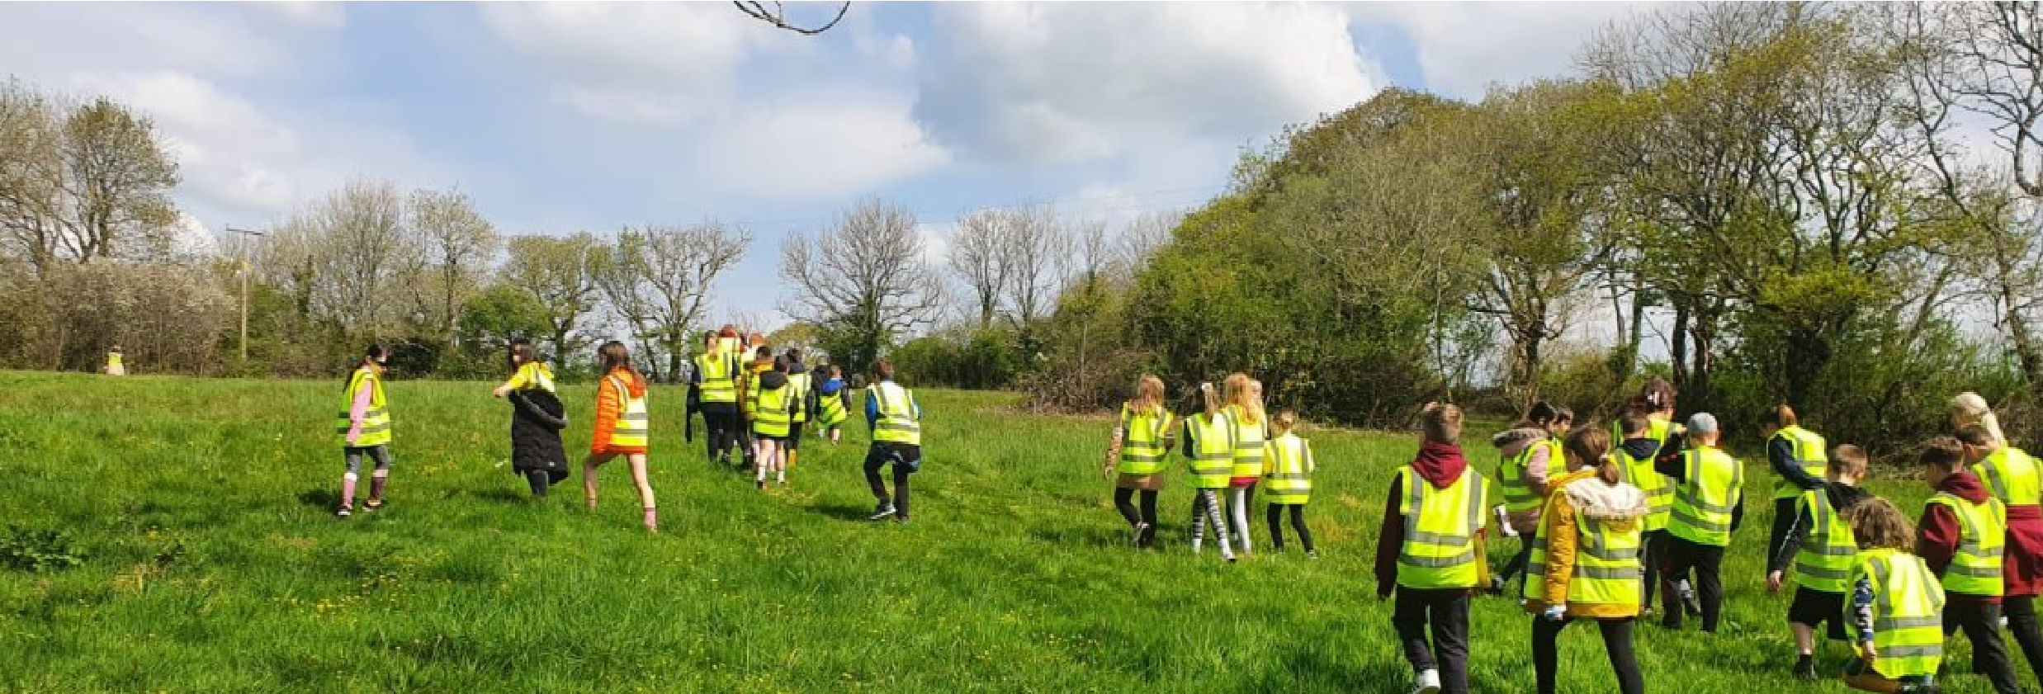
Staffing Structure
Acting Headteacher | Mr Ross Williams
Senior Teacher (ALNCO) & Dosbarth Morlo Teacher | Mrs Hayley Griffithis
Dosbarth Morlo | Mrs Amy Rodriguez
Dosbarth Ser Mor Teacher | Mrs Sara Makepeace
Dosbarth Dolffin Teacher | Mrs Rebekah Andrew
School Secretary, LTS, After-School | Mrs Donna Millward
HLTA | Miss Natalie Oriel
LSA | Mrs Katherin Davies
LSA | Miss Natalie Lewis
LSA | Mrs Jemma Ramsey
Caretaker | Mrs Elaine Jones
Cook | Mrs Kerry Moore
The school undertakes regular monitoring of all absences, including holiday absences. Parents are required to either telephone the school or use the absence form on our school app if a child is unwell on the first day of absence.

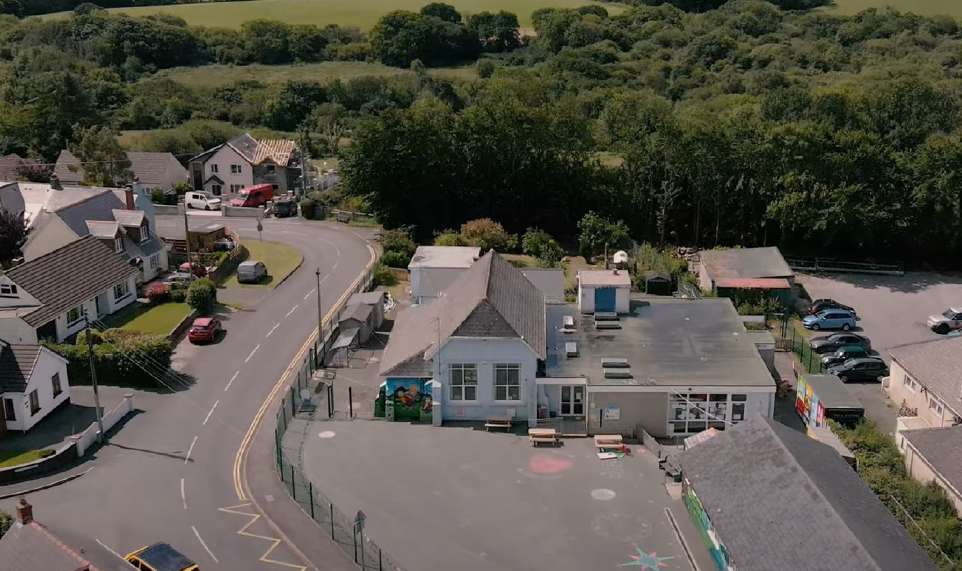
To ensure the safety of pupils, the school supports this with a ‘First Day’ response message / call if no reason for absence is provided. We are grateful for parents’ co-operation in this matter.
Attendance

The Governing Body have adopted the Welsh Government Attendance Policy guidelines. All local authorities are working to improve attendance and prevent unnecessary absences. If a child’s attendance drops below 96%, their potential and success is compromised.
 | 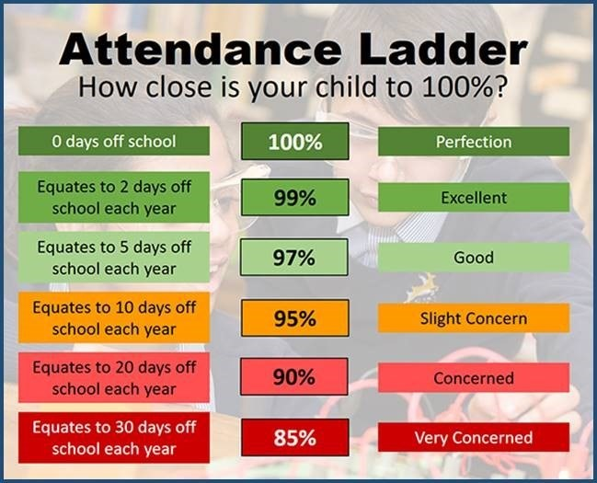
  Attendance Figures for 2024 / 2025
  (School Age 5+)
  Attendance | Authorised absence | Unauthorised  Absence
  93.96% | 3.57% | 0.54%

School Development Plan 2024—2025

The school produces a SDP to highlight the priorities for the year. Last year, the priorities were as follows:

- Further raise standards in teaching and learning. Focus on retrieval practice.
- Provision is refined for independent learning across the school to ensure there is appropriate challenge for all pupils
- Develop use of Welsh throughout the school in order to improve pupils’ skills in speaking Welsh
- Continue to refine our curriculum to ensure the principles of progression support planning, learning and teaching.
- Develop quality outdoor learning and experiences for all pupils to enable their development as heathy confident individuals.

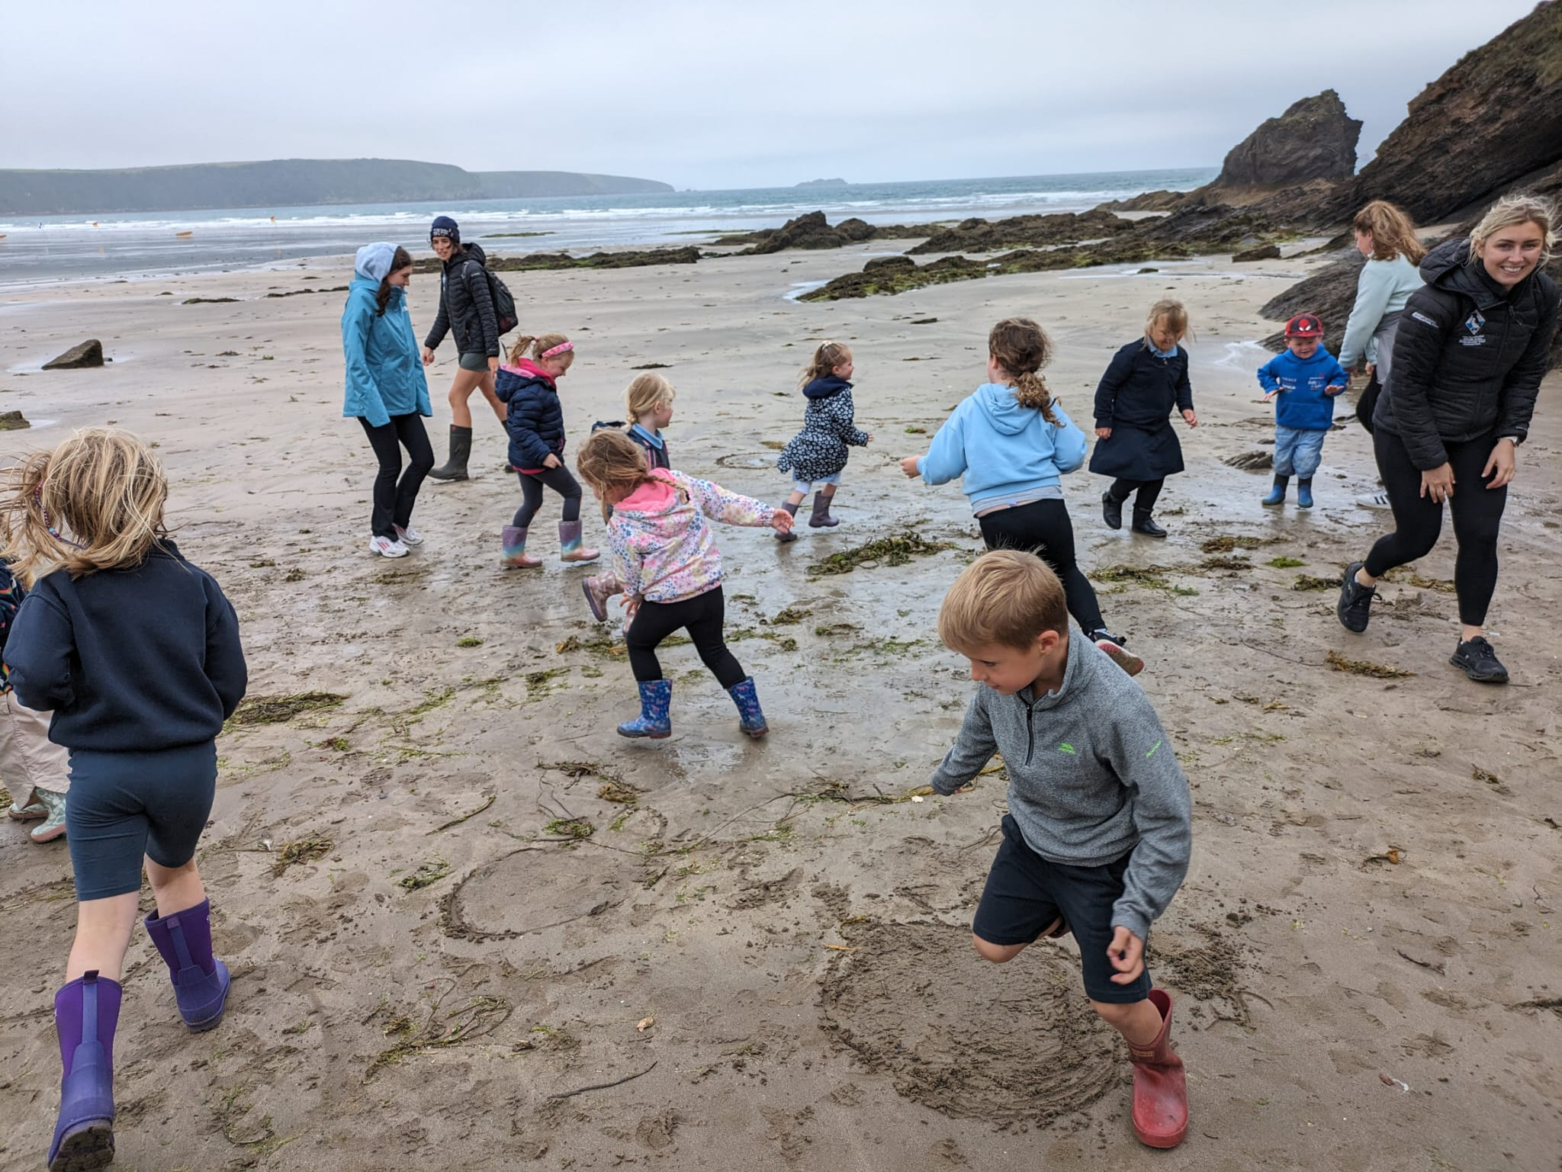
Assessment

Following the introduction of Curriculum for Wales the Welsh Government removed the requirement to report on the National Curriculum.
As a school, we have our own assessment routines that form our assessment cycle. The assessment windows each year are November and May. Pupils across the school take part in paper and online assessments that help us measure progress within literacy, numeracy and non-verbal reasoning. We also regularly assess pupil wellbeing across the school.

Reporting to Parents
The school follows Welsh Government Guidance whilst reporting progress to parents. Our reporting cycle is:
- Autumn Term 1—Meet the Teacher face-to face meeting
- Spring Term—full parents’ evening appointments
- Summer Term—full end of year school report with an option to request a face-to-face meeting if required.

Promotion of Healthy Eating, Health and Hygiene
Healthy eating is promoted throughout the year through curriculum learning opportunities, outlined in our RSE code.
These experiences include children cooking meals. Healthy lunchboxes are encouraged. There is a constant availability of water from the water cooler and during dinner time in the dining hall.
School health checks remain a consistent feature for our younger pupils and we work closely with external organisations to support this.
School dinners are prepared fresh, on site by our school cook. School dinners are carefully planned by Pembrokeshire County Council to ensure meals are balanced, nutritious and healthy.

Sport and Physical Activity
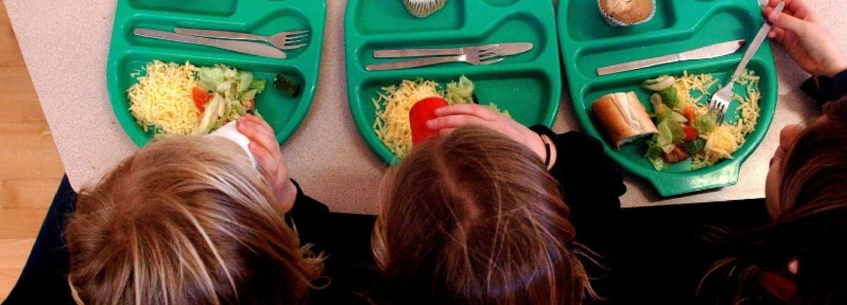
All pupils participate in weekly sessions both indoors and outdoors. Sporting fixtures with other schools are regular features. In addition, we ensure our pupils have the opportunity to attend most sporting events.
Additionally, we ensure pupils experience new activities such as Gymnastics, Yoga and Dance.

Environmental Enhancements
Since January 2022, we have worked hard to improve the school building and grounds. Parents make positive comments about the changes that are visible. We believe firmly that in order for pupils to learn, the environment must be right.

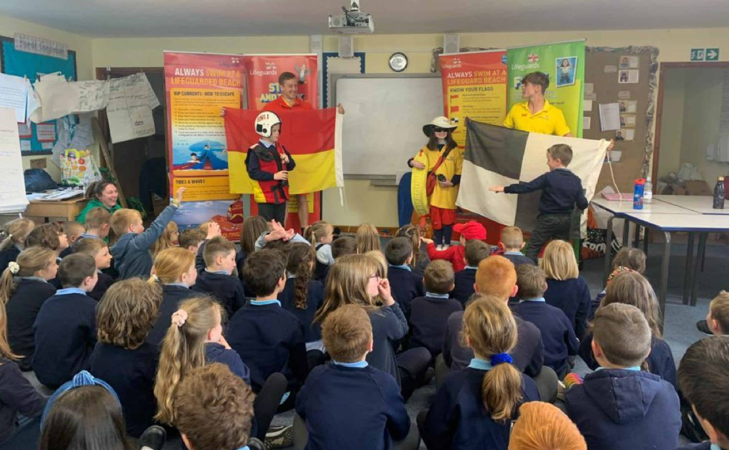
Safeguarding

Working with Pembrokeshire County Council, we have made some structural changes to building with more improvements planned over the coming months.
We are extremely grateful to parents and community members for their ongoing support with this work. Together, we have made lasting improvements that will improve learning and teaching for all.
The schools lead designated safeguarding person is Mr R Williams and the deputy designated members of staff are Mrs H Griffiths and Mrs A Rodriguez. Mrs S Burt is the link Governor for safeguarding.
Robust recording and reporting systems are in place to ensure effective practice. All staff across the school complete annual safeguarding training and safeguarding awareness is an ongoing feature of day to day school life. Safeguarding concerns regarding pupils, parents and staff can be raised with the Headteacher and designated safeguarding leads.
Safeguarding concerns regarding the Headteacher should be raised with Mrs A Harries, Chair of Governors.

Security
The school has a perimeter security fence with controlled access systems in place. External doors are controlled access also. An intercom system is used to gain entry to the school site. Further controlled access systems were installed on most external doors (except direct classroom access doors to outside learning area) during the summer of 2023.

Complaints
The school has a Complaints Procedure policy in place that can be obtained from the school office or on our website.
Care and Support
Pupils feel safe and included at Hook C. P. School because they are able to develop strong relationships with each other as well as all adults.
They are known throughout the school and are accepted and appreciated as an individual. We believe strongly in the development of social and emotional development. This is reflected in the way in which our pupils are willing to take risks in their academic and personal lives.
Everybody in the school knows each pupil’s name and can talk about each child in detail. We believe this positively impacts on achievement and results in a greater chance of success.
Children have personal targets and are encouraged to achieve these on a weekly basis. We know this routine allows pupils to move forward with their learning.

Additional Learning Needs
Mrs Griffiths is the Additional Learning Needs Coordinator (ALNCO). She works with all teachers and pupils across the school to ensure that each pupil is supported and receives the guidance needed to maximise potential.








