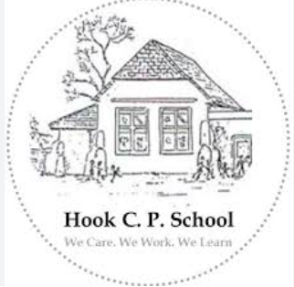
Hook Community Primary School

2025-2026 GOVERNORS’ ANNUAL REPORT TO PARENTS

We Care, We Work, We Learn.

Chair of Governors Anna Jayne Harries
c/o Hook Community Primary school
Newtown Road
Hook
SA62 4ND

Clerk to Governors
Mr Steven Richard-Downes
County Hall
Haverfordwest
SA611TP

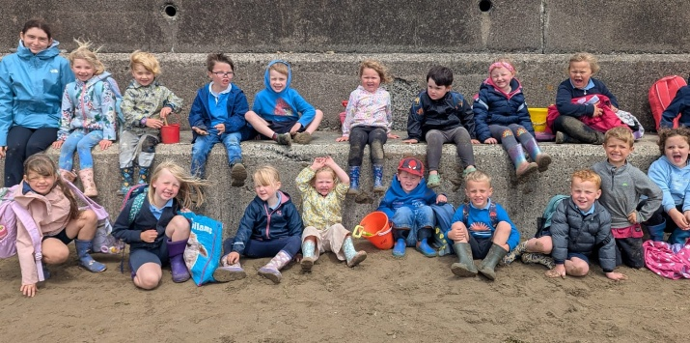

Dear Parents and Carers,

I am delighted to present the Governing Body Annual Report for the 2025-2026 academic year.

Throughout the year governors have regularly visited Hook Community Primary School to monitor progress, meet with pupils and staff, and evaluate the impact of the school development priorities. During every visit we are impressed by the confidence, enthusiasm and aspiration demonstrated by our pupils.
Pupil voice remains an important feature of school life. Children are encouraged to contribute ideas, share their views and take responsibility within the school community. Pupils speak proudly about their learning and demonstrate strong ownership of their achievements.

Hook continues to provide an engaging knowledge-rich curriculum built around high academic standards, intellectual curiosity and real-world learning experiences. A significant focus this year has been the continued development of reading, vocabulary and literacy across the school.

The school also provides a wealth of opportunities beyond the classroom through outdoor learning, sport, music, educational visits and creative projects. These experiences help pupils develop confidence, resilience and independence.
Hook Community Primary School continues to flourish because of the dedication of staff, the support of families and the hard work of pupils. On behalf of the Governing Body, thank you to everyone who contributes to the success of our school.
Yours sincerely,
Anna Jayne Harries
Chair of Governors

Your right to request a meeting with the school’s governing body

The Schools Standards and Organisation (Wales) Act 2013 (The Act) removed the requirement for school governing bodies to hold an annual meeting with parents. Instead, parents can request up to 3 meetings in any school year with a governing body, on matters which are of concern to them. If parents wish to use their rights under the Act to hold a meeting, 4 conditions will need to be satisfied:

- Parents will need to raise a petition in support of holding a meeting.
The parents of at least 10% of the school’s registered pupils will need to sign the petition. If it is a paper petition, then a written signature must be given as well as the name and class of each child who is a registered pupil at the school. If the petition is in electronic format, the ‘signature’ required is the typed name of the parent plus the name and class of each child who is a registered pupil at the school and the email address of each parent who ‘signs’ the electronic petition.

There were 80 registered as pupils with this School at the beginning of this academic year. Exact roll numbers at any time during the year may be obtained from the school office.

- The meeting must be called to discuss matters which affect the School.
The meeting cannot be called to discuss such matters as the progress of individual pupils, or to make a complaint against a member of the school’s staff or governing body. The petition should contain brief details of the matter(s) to be discussed and the reasons for calling the meeting. This information should be clearly displayed at the top of the petition, with parents’ signatures appearing below.

- The law allows parents to use their rights to request up to a maximum of 3 meetings with a school governing body during the school year.

- The law makes it a condition that at least 25 school days are left in the school year when the petition is received so that the meeting can be held.

A “school day” means a day when the school is open to pupils: it does not include weekends, public holidays, school holidays or INSET days.

The address for service of a petition requesting a meeting with this school’s Governing Body is: Chair of Governors
Hook Community Primary school
Newtown Road
Hook
SA62 4ND

Email to the Chair of the Governing Body or; Admin.Hook@pembrokeshire.gov.uk

Further advice on how parents wish may to go about requesting a meeting with a governing body is available on the Welsh Government’s website at:

http://wales.gov.uk/topics/educationandskills/publications/guidance/parentsmeetingsstatutory- guidance/?lang=e

The full list of governors is as follows:
Chair of Governors (Parent Governor) Mrs Anna-Jayne Harries
Vice Chair (Local Authority Governor) Cllr. Michael John
Acting Headteacher Mr Ross Williams
Teacher Mrs Amy Rodriguez
Community Mrs Shirley Burt
Additional Community Governor Mr Keith Hancock
Parent Mr Justin Owen-Harris
Community Mrs Rhiannon James

Election of Parent Governors:
From time to time, vacancies occur for parent representatives on the Governing Body. Any parent of a pupil registered at a school is eligible to stand as a candidate. All parents of children at the school have the opportunity to participate in the election if one is deemed necessary. The election will take the form of a secret ballot and parents are able to vote returning the ballot paper to school in a sealed envelope marked ‘voting paper’, with a pupil or by post. The LA will make the necessary arrangements for the election. Arrangements are made for the election of parent governors one school term before a parent governor’s term of office expires, or on receipt of a resignation. Information about parent elections is sent to parents via Seesaw.

Full Governing Body Meetings:
There is a requirement for the full Governing Body to meet termly (three times a year). These meetings have an agenda that is largely prescribed by the statutory requirements.

The autumn term meeting confirms the Chair and the Vice Chair.

Minutes can be requested to view, in writing, from the Chair of Governors.

Sub-committee Groups:
The sub-committee groups usually meet termly prior to the full Governing Body meetings. Each has it’s own terms of reference and are reviewed and agreed at the start of each year. Our subcommittees are;

- Standards and Curriculum
- Health and Safety.
- Finance and Staffing Committee

Previous AGPM:
An Annual Parents’ Meeting was not requested nor held during the 2024-2025 academic year.
Admissions Policy:
School Admissions at Hook Community Primary School are managed by Pembrokeshire Local Authority. Further information on the policy and how to transfer or apply for a school place can be found on the following website;

https://www.pembrokeshire.gov.uk/school-admissions

Language Category:
Hook Community Primary School is a designated English Medium school.
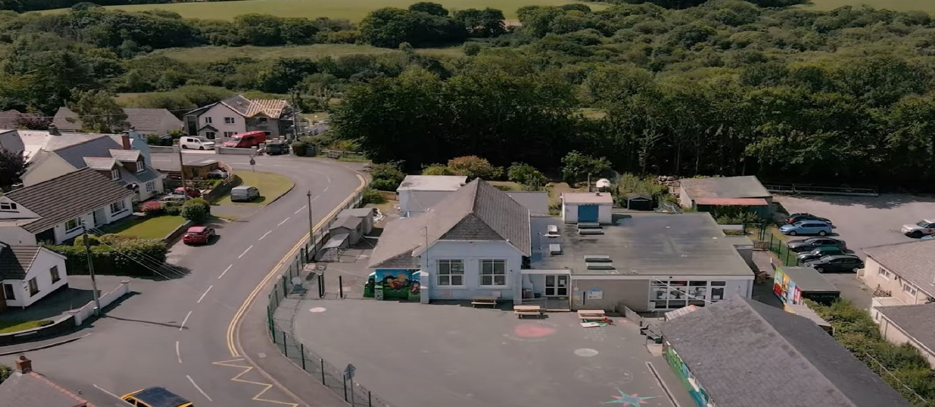
Attendance

Staff
Autumn 2025

Staffing Structure
Acting Headteacher | Mr Ross Williams
Senior Teacher (ALNCO) & Dosbarth Morlo Teacher | Mrs Hayley Griffithis
Dosbarth Morlo | Mrs Amy Rodriguez
Dosbarth Ser Mor Teacher | Mrs Sara Makepeace
Dosbarth Dolffin Teacher | Mrs Rebekah Andrew
School Secretary, LTS, After-School | Mrs Donna Millward
HLTA | Miss Natalie Oriel
LSA | Mrs Katherin Davies
LSA | Miss Natalie Lewis
LSA | Mrs Jemma Ramsey
Caretaker | Mrs Elaine Jones
Cook | Mrs Kerry Moore

Term |  | Begin | End | Mid-term break
Term |  | Begin | End | Begin | End
Autumn  2025 |  | Monday 1  September  2025 | Friday 19th December 2025 | Monday 27  October  2025 | Friday 31 October  2025
Spring  2026 |  | Monday 5  January  2026 | Friday 27  March 2026 | Monday 16  February  2026 | Friday 20  February  2026
Summer  2026 |  | Monday 13  April  2026 | Monday 20th July 2026 | Monday 25  May  2026 | Friday 29  May  2026
 | Total |  |  |  |  | 195
Term Dates 2025-26

Attendance of Years 1 to 6 pupils
 | Attendance | Authorised Absence | Unauthorised Absence
School 2025-2026 | 93.91 | 3.8 | 2.29

Attendance:
Our school target for attendance is 95%

School Development Plan Priorities’ 2025-2026
- Improve provision and accelerate skills progression across the curriculum, with a focus on effective feedback and a developing awareness of Learner Effectiveness
- To continue to develop reading provision, focusing on phonics, fluency and vocabulary development and provision across the school.
- To continue to improve pupils Welsh Language skills, improving the quality of provision across the school and supporting our aspiration to teach 10% of the curriculum through the medium of Welsh.
- To continue to develop and improve the teaching and learning of mathematics, ensuring that all pupils are making good or better progress from starting points.

Promotion of Healthy Eating, Health and Hygiene
Healthy eating is promoted throughout the year through curriculum learning opportunities, outlined in our RSE code.
These experiences include children cooking meals. Healthy lunchboxes are encouraged. There is a constant availability of water from the water cooler and during dinner time in the dining hall.
School health checks remain a consistent feature for our younger pupils and we work closely with external organisations to support this.
School dinners are prepared fresh, on site by our school cook. School dinners are carefully planned by Pembrokeshire County Council to ensure meals are balanced, nutritious and healthy.

Sport and Physical Activity
All pupils participate in weekly sessions both indoors and outdoors. Sporting fixtures with other schools are regular features. In addition, we ensure our pupils have the opportunity to attend most sporting events.
Additionally, we ensure pupils experience new activities such as Gymnastics, Yoga and Dance.

Curriculum at Hook Community Primary School

At Hook Community Primary School, we are committed to providing an ambitious, engaging and knowledge-rich curriculum that inspires children to become confident, curious and successful learners. Our curriculum is carefully designed to develop deep knowledge and understanding across all areas of learning while fostering creativity, critical thinking and a lifelong love of learning. Through meaningful and authentic learning experiences, we encourage pupils to make connections between their learning and the wider world, helping them to become ambitious, capable learners who are prepared for the future. Our approach is underpinned by our school values of We Care, We Work, We Learn, which are evident in every aspect of school life.

A key priority this year has been the continued development of reading. We recognise that reading is the gateway to all learning and have placed a strong emphasis on developing pupils' phonics, fluency, comprehension and vocabulary skills. Through high-quality teaching, rich texts and regular opportunities to read for pleasure, we aim to foster a genuine love of books while ensuring that all pupils develop the literacy skills needed to access the wider curriculum successfully.

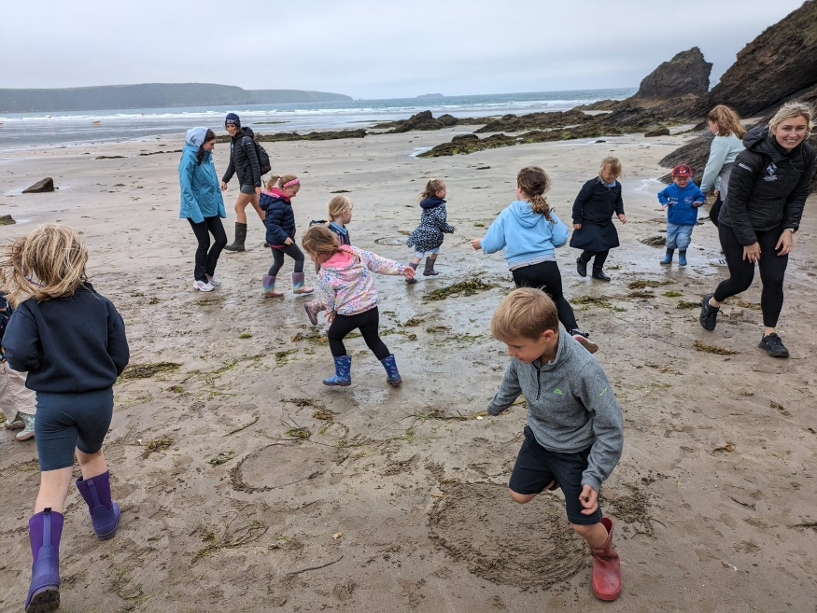
Our knowledge-rich curriculum ensures that pupils build a strong foundation of knowledge that can be applied and revisited over time. Learning is sequenced carefully so that children develop understanding progressively, enabling them to make connections across subjects and deepen their thinking. Alongside high academic expectations, pupils are provided with a wide range of opportunities to learn through enquiry, discussion, outdoor learning and real-world experiences. Hook's innovative curriculum projects and enrichment opportunities help bring learning to life, encouraging pupils to be inquisitive, resilient and enthusiastic learners.

Beyond the classroom, learning is enhanced through educational visits, visitors, outdoor learning experiences and community partnerships. These opportunities enable pupils to apply their knowledge in meaningful contexts, broaden their horizons and develop the confidence, skills and aspirations needed to thrive in an ever-changing world.

​

Safeguarding Responsibility
The schools lead designated safeguarding person is Mr R Williams and the deputy designated members of staff are Mrs H Griffiths and Mrs A Rodriguez. Mrs S Burt is the link Governor for safeguarding.
Robust recording and reporting systems are in place to ensure effective practice. All staff across the school complete annual safeguarding training and safeguarding awareness is an ongoing feature of day-to-day school life. Safeguarding concerns regarding pupils, parents and staff can be raised with the Headteacher and designated safeguarding leads.
Safeguarding concerns regarding the Headteacher should be raised with Mrs A Harries, Chair of Governors.

Care and Support
Pupils feel safe and included at Hook C. P. School because they are able to develop strong relationships with each other as well as all adults.
They are known throughout the school and are accepted and appreciated as an individual. We believe strongly in the development of social and emotional development. This is reflected in the way in which our pupils are willing to take risks in their academic and personal lives.
Everybody in the school knows each pupil’s name and can talk about each child in detail. We believe this positively impacts on achievement and results in a greater chance of success.
Children have personal targets and are encouraged to achieve these on a weekly basis. We know this routine allows pupils to move forward with their learning.

Additional Learning Needs
Mrs Griffiths is the Additional Learning Needs Coordinator (ALNCO). She works with all teachers and pupils across the school to ensure that each pupil is supported and receives the guidance needed to maximise potential.

Health and Safety:
- Health and Safety reports are shared with the Governors at least termly.
- Risk Assessments are written for all visits/trips/visitors along with Risk Assessments for the school and other activities deemed appropriate.
- Year Six prefects act as ambassadors for Health and Safety and support daily outdoor checks for their own area and for the younger pupils.

The School Prospectus:
The school prospectus provided detailed information for parents, carers and new pupils. It is updated annually with relevant changes including new dates and changes to staff. You can find the prospectus on our website or contact the school for a copy; https://www.hookcpschool.com/

Strategic Equality Scheme Action Plan and Disability Access Plan:
The Strategic Equality Plan and Disability Access Plan are available in school and on the school website. These outline the key actions that are planned to ensure that all our pupils have equal access to all aspects of school life. These are reviewed annually at Full Governors Meetings.
Premises:
Essential maintenance has been completed where necessary and there continues to be an on-going programme of non-essential maintenance work. Any emergency responsive repairs are reported immediately to PCC repairs and maintenance. There have been no significant building works taken place during 2025-2026.

Pupil Targets:
Individual pupil targets are set annually through the annual statement review or, for some pupils, the Individual Development Plan (IDP) meeting. These are used termly in developing the pupil targets in their IDP. Annual targets are set for the school for attendance and pupil progress. Annual Review reports include individual pupil targets. Pupils from Years 2-6 carry out online personalised assessments each term, to aid teacher Professional Judgements and to identify plans moving forward. These are shared through Parent Consultations and formal reporting.

Destination of School Leavers:
Most of our children transfer to Haverfordwest High with some children transferring to other Secondary Schools due to their individual and family requirements/choice.

Asymmetric Friday
On Fridays, school finishes at 13:00. However, pupils are able to stay in school until 15:00 and engage with a range of activities.

All pupils are expected to be at school in time for the commencement of each session. However, at the beginning of each school day we strongly recommend that pupils do not arrive at school before 8.45 a.m. because staff supervision cannot be guaranteed before this time and gates are not opened. The school gate will be locked at 9.00. School will be accessed via the reception for any latecomers. The school gate will be opened at the end of the school day at 3.15

Toilets.
The school toilets are cleaned daily by the caretaker/cleaner. Soap is available at all times in classrooms and in the toilets and there are paper towels/ hand dryers. All pupils wash their hands when returning to class and prior to dinner time. The toilets are maintained to the highest standards.

Web site: https://www.hookcpschool.com/

